Tugas PBO Sesi 9

Aldi Maulana Iqbal – 2021080122

# Class Diagram

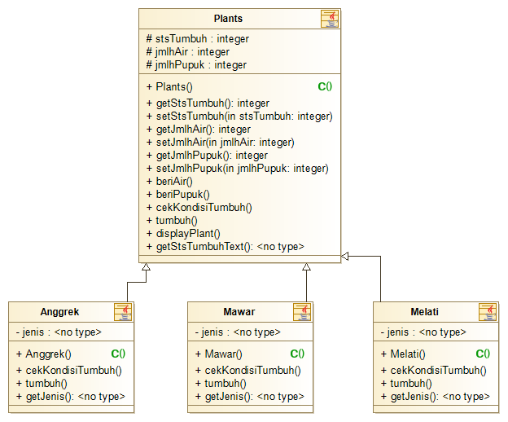

# Source Code

## Class Plants()

**class** Plants {

**protected** int stsTumbuh;

**protected** int jmlhAir;

**protected** int jmlhPupuk;

**public** Plants() {

stsTumbuh = 0;

jmlhAir = 0;

jmlhPupuk = 0;

}

**public** int getStsTumbuh() {

**return** stsTumbuh;

}

**public** void setStsTumbuh(int stsTumbuh) {

**this**.stsTumbuh = stsTumbuh;

}

**public** int getJmlhAir() {

**return** jmlhAir;

}

**public** void setJmlhAir(int jmlhAir) {

**this**.jmlhAir = jmlhAir;

}

**public** int getJmlhPupuk() {

**return** jmlhPupuk;

}

**public** void setJmlhPupuk(int jmlhPupuk) {

**this**.jmlhPupuk = jmlhPupuk;

}

**public** void beriAir() {

jmlhAir++;

cekKondisiTumbuh();

}

**public** void beriPupuk() {

jmlhPupuk++;

cekKondisiTumbuh();

}

**public** void cekKondisiTumbuh() {

**if** (jmlhAir >= 3 && jmlhPupuk >= 1) {

tumbuh();

}

}

**public** void tumbuh() {

**if** (stsTumbuh < 4) {

jmlhAir = jmlhAir - 3;

jmlhPupuk = jmlhPupuk - 1;

stsTumbuh++;

}

}

**public** void displayPlant() {

**System**.out.println(getStsTumbuhText());

**System**.out.println("Jumlah Air : " + jmlhAir);

**System**.out.println("Jumlah Pupuk : " + jmlhPupuk);

}

**public** **String** getStsTumbuhText() {

**switch** (stsTumbuh) {

**case** 0:

**return** "Status Tanaman : Benih";

**case** 1:

**return** "Status Tanaman : Tunas";

**case** 2:

**return** "Status Tanaman : Tanaman Kecil";

**case** 3:

**return** "Status Tanaman : Tanaman Dewasa";

}

**return** "Status Tanaman : Berbunga";

}

}

## Class Anggrek()

**class** Anggrek **extends** Plants {

**private** **String** jenis = "Anggrek";

**public** Anggrek() {

**super**();

jenis = "Anggrek";

}

**public** void cekKondisiTumbuh() {

**if** (getJmlhAir() >= 3 && getJmlhPupuk() >= 2) {

tumbuh();

}

}

**public** void tumbuh() {

**if** (getStsTumbuh() < 4) {

setJmlhAir(getJmlhAir() - 3);

setJmlhPupuk(getJmlhPupuk() - 2);

setStsTumbuh(getStsTumbuh() + 1);

}

}

**public** **String** getJenis() {

**return** jenis;

}

}

## Class Mawar()

**class** Mawar **extends** Plants {

**private** **String** jenis = "Mawar";

**public** Mawar() {

**super**();

jenis = "Mawar";

}

**public** void cekKondisiTumbuh() {

**if** (getJmlhAir() >= 2 && getJmlhPupuk() >= 1) {

tumbuh();

}

}

**public** void tumbuh() {

**if** (getStsTumbuh() < 4) {

setJmlhAir(getJmlhAir() - 2);

setJmlhPupuk(getJmlhPupuk() - 1);

setStsTumbuh(getStsTumbuh() + 1);

}

}

**public** **String** getJenis() {

**return** jenis;

}

}

## Class Melati()

**class** Melati **extends** Plants {

**private** **String** jenis = "Melati";

**public** Melati() {

**super**();

jenis = "Melati";

}

**public** void cekKondisiTumbuh() {

**if** (getJmlhAir() >= 2 && getJmlhPupuk() >= 2) {

tumbuh();

}

}

**public** void tumbuh() {

**if** (getStsTumbuh() < 4) {

setJmlhAir(getJmlhAir() - 2);

setJmlhPupuk(getJmlhPupuk() - 2);

setStsTumbuh(getStsTumbuh() + 1);

}

}

**public** **String** getJenis() {

**return** jenis;

}

}

## Class PlantMain()

**public** **class** PlantMain {

**public** **static** void main(**String**[] args) {

**Scanner** sc = **new** **Scanner**(**System**.in);

int pilihAksi, pilihTanaman;

**System**.out.println("|=============================|");

**System**.out.println("| Pilih Tanaman |");

**System**.out.println("|=============================|");

**System**.out.println("| 1. Anggrek |");

**System**.out.println("| 2. Mawar |");

**System**.out.println("| 3. Melati |");

**System**.out.println("|=============================|");

**System**.out.print("Masukkan Pilihan : ");

pilihTanaman = sc.nextInt();

**switch** (pilihTanaman) {

**case** 1:

Anggrek myAnggrek = **new** Anggrek();

**do** {

**System**.out.println("|=============================|");

**System**.out.println("| Sistem Penumbuhan Tanaman |");

**System**.out.println("| Anggrek (3 Air & 2 Pupuk) |");

**System**.out.println("|=============================|");

**System**.out.println("| 1. Beri Air Untuk Tanaman |");

**System**.out.println("| 2. Beri Pupuk Untuk Tanaman |");

**System**.out.println("| 9. Untuk Keluar |");

**System**.out.println("|=============================|");

**System**.out.print("Masukkan Pilihan : ");

pilihAksi = sc.nextInt();

**switch** (pilihAksi) {

**case** 1:

myAnggrek.beriAir();

**break**;

**case** 2:

myAnggrek.beriPupuk();

**break**;

}

myAnggrek.displayPlant();

} **while** (pilihAksi != 9);

**break**;

**case** 2:

Mawar myMawar = **new** Mawar();

**do** {

**System**.out.println("|=============================|");

**System**.out.println("| Sistem Penumbuhan Tanaman |");

**System**.out.println("| Mawar (2 Air & 1 Pupuk) |");

**System**.out.println("|=============================|");

**System**.out.println("| 1. Beri Air Untuk Tanaman |");

**System**.out.println("| 2. Beri Pupuk Untuk Tanaman |");

**System**.out.println("| 9. Untuk Keluar |");

**System**.out.println("|=============================|");

**System**.out.print("Masukkan Pilihan : ");

pilihAksi = sc.nextInt();

**switch** (pilihAksi) {

**case** 1:

myMawar.beriAir();

**break**;

**case** 2:

myMawar.beriPupuk();

**break**;

}

myMawar.displayPlant();

} **while** (pilihAksi != 9);

**break**;

**case** 3:

Melati myMelati = **new** Melati();

**do** {

**System**.out.println("|=============================|");

**System**.out.println("| Sistem Penumbuhan Tanaman |");

**System**.out.println("| Melati (2 Air & 1 Pupuk) |");

**System**.out.println("|=============================|");

**System**.out.println("| 1. Beri Air Untuk Tanaman |");

**System**.out.println("| 2. Beri Pupuk Untuk Tanaman |");

**System**.out.println("| 9. Untuk Keluar |");

**System**.out.println("|=============================|");

**System**.out.print("Masukkan Pilihan : ");

pilihAksi = sc.nextInt();

**switch** (pilihAksi) {

**case** 1:

myMelati.beriAir();

**break**;

**case** 2:

myMelati.beriPupuk();

**break**;

}

myMelati.displayPlant();

} **while** (pilihAksi != 9);

**break**;

**default**:

**System**.out.println("Maaf, tanaman tidak tersedia.");

**break**;

}

}

}